# 1. INTRODUCTION

Agriculture is an important source of livelihood in India. The majority of the country's population is directly or indirectly associated with the agricultural sector. Hence, producing high-quality agricultural yield is necessary to sustain the country's economic development.1 [1]. To overcome this problem the crops needs to be monitored against diseases, the method used to monitor the plants from diseases was traditional naked eye observation that is time consuming technique which requires experts to manually monitor the crop fields. In west Maharashtra agricultural and forestry experts are used to identify on- site or farmers identify leaves diseases based on experience. This method is not only subjective, but also time consuming, laborious and inefficient. Farmers with less experience may misjudgment and the identification processes Quality and output which will cause unnecessary economic losses to counter

these challenges, research into the use of image processing techniques for plant disease recognition has a become hot research topic .[2]

Fig 1.1 Traditional Image Processing.

The general process of using traditional image recognition processing technology to identify plant diseases is shown in Fig. 1.1.

**1.1 General Process**

**1.1.1 Image acquisition**- Image acquisition is the process through which we obtain a digital representation of a scene. This representation is known as an image, and its elements are called pixels (picture elements).

**1.1.2 Image Processing-** Image processing is the process of transforming an image into a digital form and performing certain operations to get some useful information from it. The image processing system usually treats all images as 2D signals when applying certain predetermined signal processing methods [3].

**1.1.3 Feature Extraction-** It is a type of dimension reduction technique that effectively represent the useful part of the image. [1] Various features such as texture, color, edges and morphology can be extracted for the detection of plant disease. Color co-occurrence method is used for feature extraction The features can be divided into four types; Geometric features, Statistical features, Texture features ,and Color features. [4]

**1.1.4 Identification & Classification-** Identification is the activity and analytical process of being able to recognize an unknown object and name it. Classification is the statistical analysis leading to being able to place an unknown object into a category (defined by known and quantified parameters) of objects.[5]The Proposed methodology holds a new dataset of images containing of Tea leaves. The dataset was named Tea Leaves Diseases Dataset and can be downloaded from the kaggle. Having a high quality dataset is essential for obtaining a good classifier most of the dataset with images.The proposed dataset containing 7 classes and each class contains minimum 40 images. The names of classes are red leaf spot, gray blight, white

spot, brown blight, algal leaf spot, Anthracnose, bird's eye spot.The Proposed methodology uses AlexNet and GoogleNet first import the tea leaves dataset into the AlexNet as an ImageDataStore object. An image datastore enables you to store large image data, including data that not fit in memory, and efficiently read batches of images during training of a convolutional neural network.

**1.2 Overview**

Proposed methodology uses Tea Leaves Disease Classification dataset classify seven types of diseases like red leaf spot, gray blight, white spot, brown blight, algal leaf spot, Anthracnose, bird's eye spot each class contain minimum 40 images proposed methodology compute tea leaves diseases identification by using AlexNet and GoogleNet. The methodology proposed Convolutional Neural Network (CNN) to improve accuracy further experimental results show the detection and identification accuracy Of AlexNet and GoogleNet for tea Leaves diseases.

**1.3 Motivation**

The motivation that recognition of leaves unhealthiness is the solution for saving the

Reduction of crops and productivity.

**1.4 Problem Definition and Objectives**

**1.4.1. Problem Definition**

To detect Tea leaves diseases using leaf images manually it is very time consuming and

slow process hence, It required computational method which will make the process of

diseases detection and classification using leaf images automatic.

**1.4.2. Objective**

To classify the Alexnet by using Tea Leaves Dataset.

To classify the GoogleNet using Tea Leaves Dataset.

To identify Tea Leaves diseases using Conventional Neural Network.

To classify Tea Leaves diseases using eight classes are as follow- Red leaf spot, Gray blight,

White Spot, Brown blight, Algal leaf spot, Anthraonose, Bird’s eyespot, Healthy.

**1.5 Project Scope & Limitations**

Proposed methodology combined the corresponding agricultural knowledge, images of diseased leaves can we used of as input convolutional neural network (CNN)to train the identification model. Proposed methodology compare accuracy of AlexNet and GoogleNet.

**1.6 Methodologies of Problem solving**

* We are implementing the dataset using image data, computer vision, deep learning, multiclass classification.
* We are using Alexnet to Identifying Disease in Tea leaves dataset.
* We are using Alexnet to Identifying Disease in Tea leaves dataset.
* We are comparing alexnet and google net accurancy by our model and comparing their accurancy.

**2. Literature Survey**

|  |  |  |  |  |  |
| --- | --- | --- | --- | --- | --- |
| **Literature Survey Table**  **1** | | | | | |
| Sr.No | Year | Authors Name | Description | Merits | Demerits |
| 1 | 2020 | Vagisha Sharma, Amandeep Verma, Neeelam Goal | Different techniques which are used to classify plant disease | Discussed the Monocotyledonous and Dicotyledonous plant families along with the related methodology encompassing of the image processing steps | Limited Classes are provide for identification. |
| 2 | 2020 | Jing Chena, Junying jia | Tea leaf Identification on bovw. | Gives real time performance and simple and easy to implement algorithm. | 1. In this manuscript, the expansion process of sample data is a time-consuming process 2. Identify less plant diseases |
| 3 | 2021 | Jun liu, Xvewel Wong | Identify diseases and pest classification | The advantages of this method were that occurrence of multiple diseases on the same leaf could be detected and the data can be augmented by cutting up the leaf image into multiple sub-images. | The network structure is relatively complex and a pixel by pixel label is required |
| 4 | 2021 | SK Mahmudal Hassan, Michel Jasnki | Proposed two methods shallow VGG with RF and VGG with xgbooost | One of the major advantages in the proposed model is that, the model performs better with fewer parameters in comparison with  VGG19 and other deep learning | The parameter generated in this model is much higher, which implied the higher computational cost. |
| 5 | 2022 | Wenxia Bao,Tao Fan | This paper proposed an improved RetinaNet target detection and identification network | Although RetinaNet achieved better results compared with the existing classical networks | Some useful features will be missed, which will affect the detection and recognition effect of the networks |

**2.1. Literature Surveys Summary**

**Paper No.1:** Classification Techniques for plant disease. Vagisha Sharma, Amandeep Verma, Neeelam Goal are the authors of this research paper. This paper was published in 2020.

Method or algorithms are usedin this paper areSupport Vector Machine (SVM), K-Nearest Neighbor (K-NN)

* The image processing steps for plant disease identification include acquiring of images, pre-processing, segmentation and feature extraction.
* In this review paper, they focused mainly on the most utilized classification mechanisms in disease detection of plants such as Support Vector Machine, K Nearest Neighbor, and Artificial Neural Network.
* It has been observed from the analysis that provides better accuracy compared to the traditional approaches..
* The learning from unaltered and smaller dataset with CNNs yields surprisingly better results.

Features /Advantages:

* Discussed the Monocotyledonous and Dicotyledonous plant families along with the related methodology encompassing of the image processing steps
* Accuracy has been achieved with the deep learning concepts.

Conclusion of this paper is the most recent work has been analyzed and it is depicted in the form of tables. It can be concluded that amongst the techniques that have been used in the existing work done, highest accuracy has been achieved with the deep learning concepts.

**Paper No.2:** Automatic Recognition of Tea Diseases Based on Deep Learning. Jing Chen and Junying Jia are the authors of this research paper. This paper was published in 2021.Technologies are used in this paper are Deep tea leaf disease, deep learning, convolutional neural network, dense SIFT, bag of visual word.Method or algorithms are usedin this paper areBOVW model**.** Presented many imaging techniques for plant disease detection, and the focus was on imaging techniques.

* Image feature extraction and description: Local feature vectors of the entire training set image are obtained through methods such as point-of-interest detection, dense sampling, or random sampling. Commonly used local features include SIFT descriptor and SURF descriptor.
* Construct a visual vocabulary: After obtaining the local feature vectors of all sample images, use the k-means algorithm to cluster the local feature vectors. The k-means algorithm is an unsupervised learning algorithm. It divides the data into different categories through an iterative process and then calculates the Euclidean distance between each data and various types of centers . The smaller the distance, the higher the similarity. k represents the number of clusters, and means represents the mean of the data in the clusters. If there arek cluster centers (i.e., visual words), then the size of the visual vocabulary is also k. This manuscript selects 1000 visual words, and the size of the visual vocabulary is 1000.

Features /Advantages:

* The advantage of deep learning is that it does not require aritifical feature extraction but this is obtain automatically by network.
* Gives real time performance and simple and easy to implement algorithm.

Conclusion of this paper is feature extraction is an important step in image classification and directly affects classification accuracies. Thus, two feature extraction methods and three classifiers were compared in their abilities to identify seven tea leaf diseases in the present manuscript.

**Paper No.3:** Plant Diseases and Pest detection based on deep learning. Jun liu, Xvewel Wong are the authors of this research paper. This paper was published in 2021.Technologies used in this paper are Deep learning, plant leaf disease detection, visualization, small sample. Method or algorithms used Support Vector Machine (SVM), K-means, and KNN

* Presented many imaging techniques for plant disease detection, and the focus was on imaging techniques.
* The major techniques presented for plant diseases and classification are SVM, K-means, and KNN.
* Presented many developed/modified DL architectures implemented to detect and classify plant diseases.
* Present the current trends and challenges for the detection of plant leaf disease using deep learning and advanced imaging techniques.

Features /Advantages:

* Valuable resource for researchers who study the detection of plant diseases and

Insect pests.

* The advantages of this method were that occurrence of multiple diseases on the

same leaf could be detected and the data can be augmented by cutting up the leaf image into multiple sub-images.

Conclusion of this paper that they introduced the basic knowledge of deep learning and presented a comprehensive review of recent research work done in plant leaf disease recognition using deep learning. Provided sufficient data is available for training, deep learning techniques are capable of recognizing plant leaf diseases.

**Paper No.4:** Plant disease identification using shallow convolutional neural network**.** Sk Mahmudul Hassan, Michal Jasinski , Zbigniew Leonowicz , Elzbieta Jasinska and Arnab Kumar Maji are the author of this paper. This paper is published in 2021.Technologies are used in this paper are Deep learning; machine learning; transfer learning; support vector machine; random forest.Method or algorithms used Visual Geometry Group (VGG19), Extreme Gradient Boosting (Xgboost), Random Forest (RF).

* Visual Geometry Group (VGG) is a widely used deep learning model amongst all the models and also highly portable in nature.
* Though VGG is a simple architecture with convolution and pooling layers, the number of parameters generated in the VGG network is relatively high and it is more than 140 million.
* The author showed that instead of using a large deep network, shallow CNN provide enough feature information to classify.
* Instead of training the model with randomly initialized weights, we have used the pre-trained network which is trained on a large dataset.
* They have used only 7 convolution and 2 pooling layers from the pre-trained network**.**

Features /Advantages:

* One of the major advantages in the proposed model is that, the model performs better with fewer parameters in comparison with VGG19 and other deep learning models.
* The proposed model has an advantages in accuracy, precision, recall, and f1-score. Finally, a comparative analysis of the implemented model, with other deep learning models, and traditional hand-crafted based approaches is carried out.

Conclusion of this paper that they proposed two models namely shallow VGG with RF and shallow VGG with Xgboost to identify the diseases in plants. We have modified the pre-trained VGG19 model and used first nine layers and replaced the rest layers with a global average pooling layer.

**Paper No.5:** Plant Detection and identification of tea leaf diseases based on AX-Retina Net**.** Wenxia Bao, Tao Fan, Gensheng Hu*, Dong Liang & Haidong Li are the author of this paper. This paper is published in 2022. Technologies are used in this paper are AX-RetinaNet, Image, Detection. Method or algorithms used areAX-RetinaNet.

* AX-RetinaNet is constructed based on RetinaNet by adopting an improved feature fusion module X-module and adding a channel Attention module. Tis study conducted ablation experiments to analyze the impact of these two modules on detection and identifcation performance.
* AX-RetinaNet uses an improved multiscale feature fusion module X-module to fuse the multiscale features of tea leaf diseases and obtain features of the diseases with rich semantic information
* AX-RetinaNet adds a channel Attention module, which adds adaptively optimized weights to each feature map channel to ensure that the network pays attention to useful feature information and reduces the interference of redundant information.
* Te data augmentation method is used to expand the number of training images to solve the problem of insufficient samples and improve the network detection and identification effect. .
* Te method used in this study provides a basis for the automatic prevention and control of tea leaf diseases and is conducive to the rational use of pesticides.

Features /Advantages:

* Although RetinaNet achieved better results compared with the existing classical networks.
* The automatic detection and identification of tea leaf diseases in natural scene images, and traditional hand-crafted based approaches is carried out.

Conclusion of this paper is Tea leaf diseases have severely affected the yield and quality of tea. Automatic detection and identification of tea leaf diseases with high accuracy is conducive to precise prevention and control of the diseases. Existing CNNs have low accuracy in detecting and identifying tea leaf diseases in natural scene images because of the problems.

**03. SOFTWARE REQUIREMENTS SPECIFICATION**

**3.1. INTRODUCTION**

The software requirements are description of features and functionalities of the target

system. Requirements convey the expectations of users from the software product. The requirements can be obvious or hidden, known or unknown, expected or unexpected from client’s point of view.

**3.2. Functional Requirements-**

**3.2.1 Matlab:**

MATLAB is an abbreviation for "matrix laboratory." While other programming languages usually work with numbers one at a time, MATLAB® operates on whole matrices and arrays. Language fundamentals include basic operations, such as creating variables, array indexing, arithmetic, and data types.

**Uses:**

* Math and computation.
* Algorithm development.
* Modeling, simulation, and prototyping.
* Data analysis, exploration, and visualization.
* Scientific and engineering graphics.
* Application development, including Graphical User Interface building.

MATLAB® is a programming platform designed specifically for engineers and scientists to

analyze and design systems and products that transform our world. The heart of

MATLAB is the MATLAB language, a matrix-based language allowing the most natural

expression of computational mathematics.

**3.2.2 Hardware Interface**

RAM: 8 GB

As we are using Machine Learning Algorithm and Various High-Level Libraries Laptop-RAM minimum required is 8 GB.

Data Set images

Processor: Intel i5 Processor

IDE: Matlab

Best Integrated Development Environment as it gives possible suggestions at the time of typing code snippets that makes typing feasible and fast.

Coding Language: Python Version 3.5

Highly specified Programming Language for Machine Learning because of avail- ability of High-Performance Libraries.

Operating System: Windows 10

Latest Operating System that supports all type of installation and development Environment

**3.3. Nonfunctional Requirements-**

**3.3.1 Performance Requirements**

The performance of the functions and every module must be well. The overall performance of the software will enable the users to work efficiently. Performance of encryption of data should be fast. Performance of the providing virtual environment should be fast Safety Requirement

•The application is designed in modules where errors can be detected and easily. This makes it easier to install and update new functionality if required.

**3.3.2 Safety Requirements**

The application is designed in modules where errors can be detected and fixed easily. This makes it easier to install and update new functionality if required.

**3.3.3 Security Requirements**

Information security means protecting information and information systems from

unauthorized access, use, disclosure, disruption, modification or destruction.

1. All the user details shall be accessible to only high authority persons.

2. Access will be controlled with usernames and passwords.

**3.3.4 Software Quality Attributes**

Our software has many qualities attribute that are given below: -

1.Accuracy: This software gives more accuracy.

2.Adaptability: This software is adaptable by all users.

3.Availability: This software is freely available to all users. The availability of the software is easy for everyone.

4.Maintainability: After the deployment of the project if any error occurs then it can be easily maintained by the software developer.

5.Reliability: The performance of the software is better which will increase the

reliability of the Software.

6.User Friendliness: Since, the software is a GUI application; the output generated is much user friendly in its behavior.

7.Integrity: Integrity refers to the extent to which access to software or data by unauthorized persons can be controlled.

9.Security: Users are authenticated using many security phases so reliable security is provided.

10.Testability: The software will be tested considering all the aspects.

**3.4. System Requirements-**

**3.4.1 Software Requirements**

* Operating System: Windows 10

* IDE: Matlab.

**3.4.2 Hardware Requirement**

* Processor: i3 processor onwards

* RAM: 8GB

* Any PC or Laptop

**3.5. SDLC Model-**

**3.5.1 Waterfall Model:**

This project makes use of waterfall model. It involves following steps. In a waterfall model, each phase must be completed fully before the next phase can begin. This type of software development model is basically used for the project which is small and there are noun certain requirements.

**3.5.1.1 Requirement gathering:**

All the functional and non-functional requirements of the project were identified. Interaction with the users and all other stakeholders of the project was conducted to identify all the requirements starting from important features like maintaining audit trail, security parameters etc. to the very basic features like the look and the feel of user interface. The different requirements. Mainly fall into categories:

1. System features

2. Database requirements

3. Security parameters

4. User requirements

5. Administrator requirements

6. User interface

**3.5.1.2 Design:**

The first step was collection. Fresh and latest data is required for the implementation of this project. The second step was project design. The project was designed based on a framework.

**3.5.1.3 Construction:**

a) Integration and system testing:

All the modules were integrated together. The user interface was integrated with the modules which made the use web services. Data flow originated from the amazon.in website. In testing phase project was tested and debugged. Various test cases were developed and the project was tested at the developers end as well as users end. Debugging was done to discover errors and exception which were corrected.

b) Installation and maintenance:

Our system is installed on one dedicated machine and it is accessible to admin and all authenticated users. Maintenance of our system is done on regular basis. New requirements and features can be added as and when required as long as they do not conflict with the existing features.

**04. SYSTEM DESIGN**

**4.1 System Architecture:**

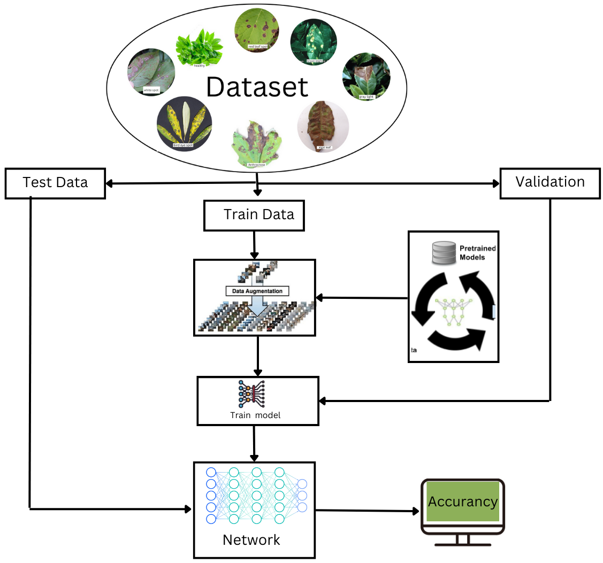

Fig.4.1 System Architecture

In this system architecture dataset consist of seven classes of diseases. Dataset has been split into train, test and validation. Data augmentation is done for image rotation. Later model have been trained, test and validation data has done. Then pretrained model comes under training, testing and validation. Pretrained network AlexNet and GoogleNet are trained. Own network comes under execution and start model training, testing and validation. After execution of these networks model gets accurancy of AlexNet, GoogleNet and Own Network.

**4.1.1 Module**

**4.1.1.1 Dataset**

A [Dataset](http://www.pymvpa.org/generated/mvpa2.datasets.base.Dataset.html) is the basic data container in PyMVPA. It serves as the primary form of data storage, but also as a common container for results returned by most algorithms. In this tutorial part we will take a look at what a dataset consists of, and how it works.

Most datasets in PyMVPA are represented as a two-dimensional array, where the first axis is the [sample](http://www.pymvpa.org/glossary.html)s axis, and the second axis represents the [feature](http://www.pymvpa.org/glossary.html)s of the samples. In the simplest case, a dataset only contains data that is a matrix of numerical values.

**4.2. Entity Relationship Diagram**

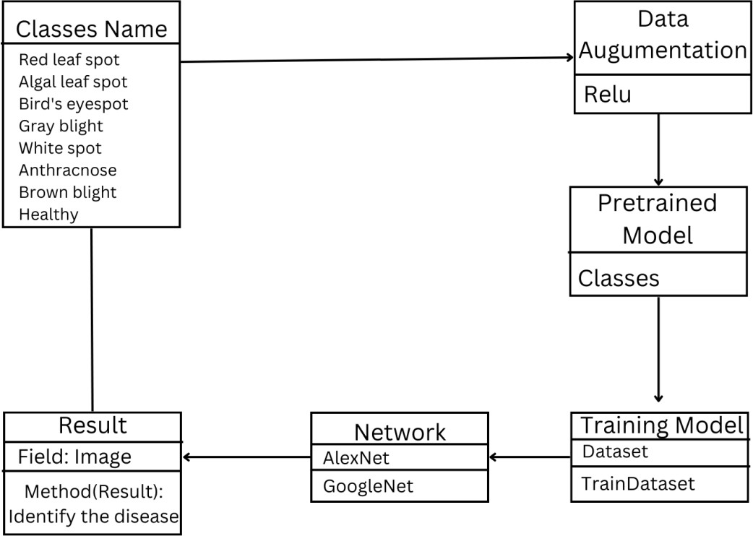

Fig 4.2 Entity Relationship diagram

## 4.3. Data Flow Diagram

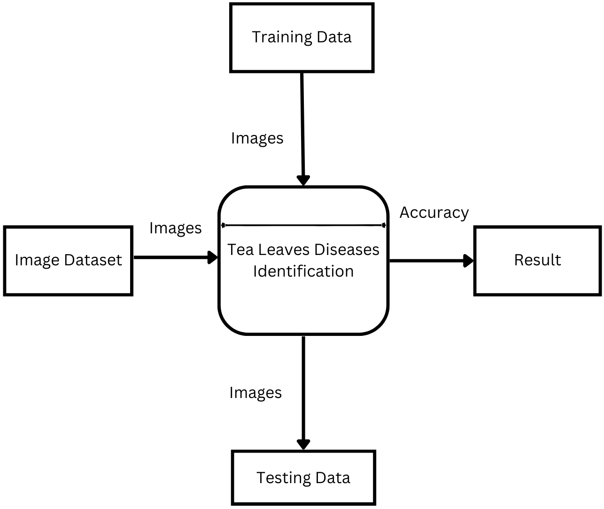

Fig 4.3 Data Flow(0)diagram

**4.3.1. Data Flow (1) diagram**

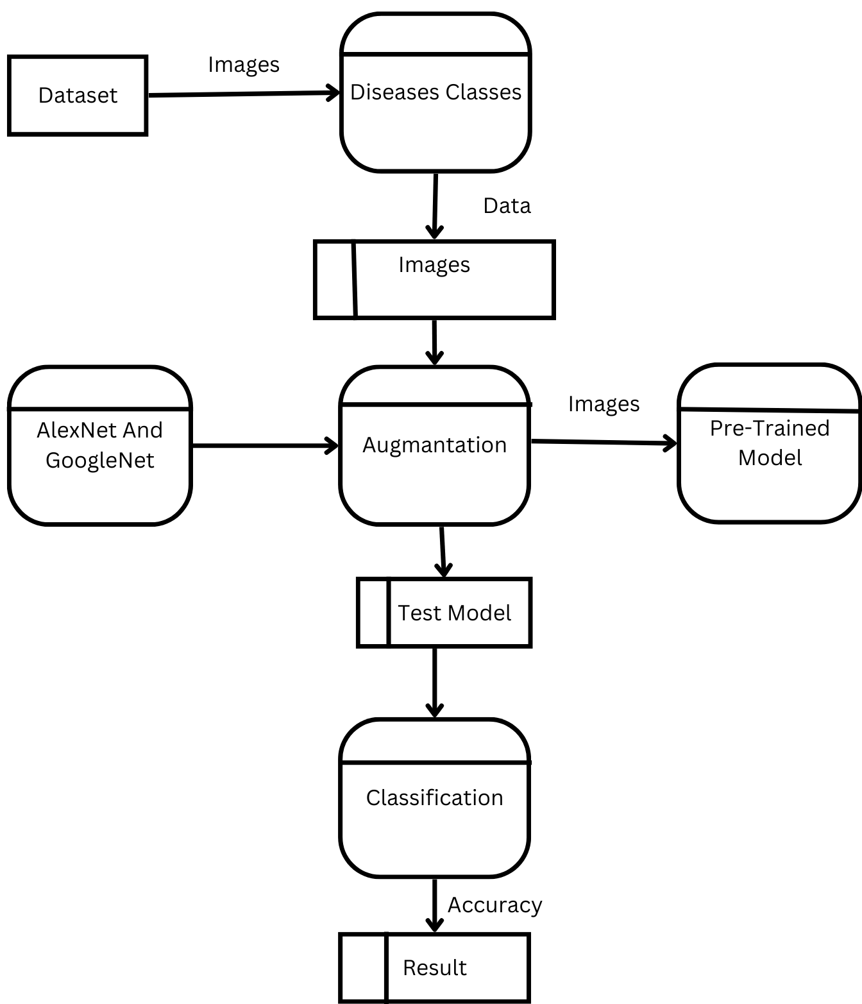

Figure 4.3.1 Data Flow(1)diagram

## 4.4. Use Case Diagram-

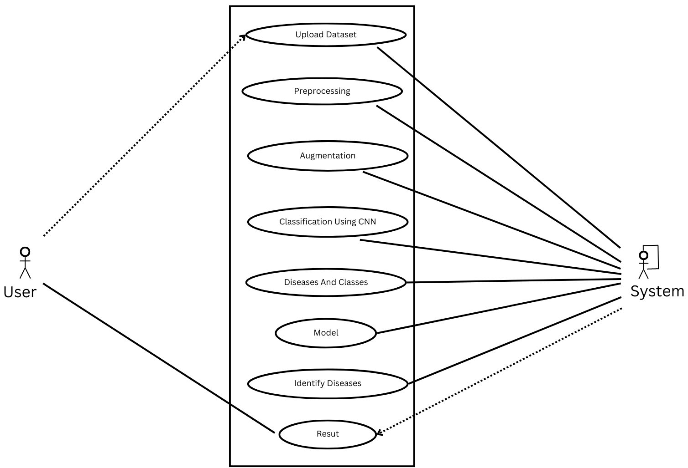

Fig 4.4 Use Case Diagram

## 4.5. Activity Diagram-

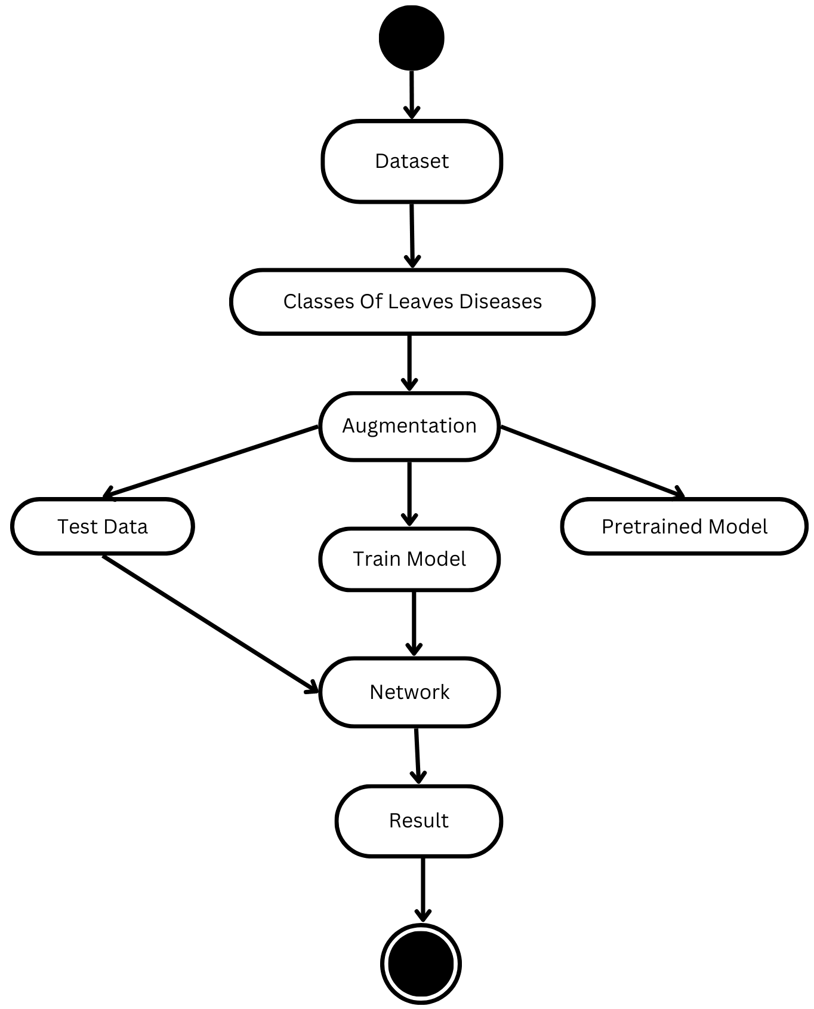

Fig 4.5 Activity diagram

**05. PROJECT PLAN**

**5.1 Project Estimate:**

Project estimation for Tea leaves disease detection can vary depending on several factors, such as the size and complexity of the input data, the algorithm to be used, the level of expertise of the development team, and the project scope. However, here are some general steps that can be taken to estimate the project for leaves disease detection:

1. Project scope and requirements: Proposed methodology combined the corresponding agricultural knowledge, images of diseased leaves can we used of as input convolutional neural network (CNN) to train the identification model. Proposed methodology compares accuracy of AlexNet and GoogleNet.

2. Data collection and preparation: Collect the required data, such as Leaf images and preprocess them for analysis. Estimate the time required for data cleaning, transformation, and integration.

3. Algorithm design and implementation:

4. Documentation and deployment: Document the project requirements, design, implementation, and evaluation. Estimate the time required for documentation, deployment, and maintenance.

Based on these steps, the project estimate for Tea leaves disease detection can range from a few weeks to several months, depending on the complexity and scope of the problem. The cost can vary depending on the hourly rates of the developers, the hardware and software infrastructure required, and other overhead costs.

**5.1.1 Reconciled estimates**

1. Project scope and requirements: 2 weeks

2. Data collection and preparation: 3 weeks

3. Algorithm design and implementation: 7 weeks

4. Optimization and tuning: 5 weeks

5. Documentation and deployment: 3 weeks

Total estimated project duration: 20 weeks (5 months)

**5.2 Project Schedule**

**5.2.1 Project Task Set**

1. Define the problem statement and project requirements, including the input and output formats, constraints, and optimization objectives.

2. Collect and preprocess the required data, such as Tea leaves images.

3. Choose the appropriate algorithm or methodology for the Tea leaves disease detection, such as CNN algorithm.

4. Implement the algorithm in the selected programming language and ensure that it meets the project requirements.

5. Test the algorithm with sample data and validate the results.

6. Develop for inputting and visualizing the results of the Tea leaves disease detection.

7. Document the project requirements, design, implementation, and evaluation, and deploy the software to the production environment.

**5.2.3 Task Network**

1. Define problem statement and project requirements.

2. Collect and preprocess data

a. Identify data sources

b. Obtain data from sources

c. Clean and transform data

3. Choose algorithm or methodology for Tea leaves disease detection

a. Review existing algorithms and methodologies

b. Select appropriate algorithm or methodology

4. Implement algorithm in programming language

a. Design algorithm

b. Write code

5. Test algorithm with sample data

a. Develop test cases

b. Test algorithm with test cases

c. Verify correctness of algorithm

6. Fine-tune algorithm parameters

a. Analyze algorithm performance

b. Identify parameters to adjust

c. Adjust parameters

7. Document project requirements, design, and implementation

a. Create documentation templates

b. Write project documentation

**06. PROJECT IMPLIMENTATION**

**6.1 Overview of Project Modules**

**6.1.1 AlexNet**

Alexnet contains 22 layers. The layers are Input Layer, Convolutional fully connected, normalization layer, Pooling Layer…etc

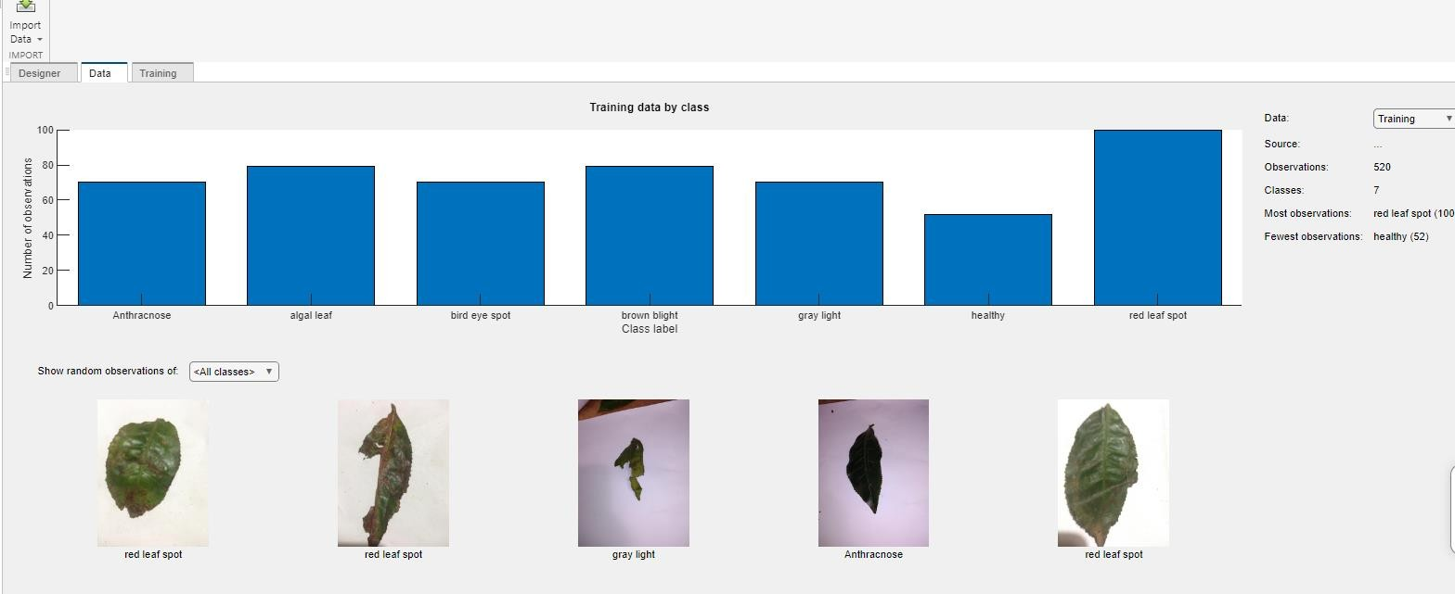

Fig 6.1 Training Data By Classes

The network has learned rich feature representations for a wide range of images. The network takes an image as input and outputs a label for the object in the image together with the probabilities for each of the object categories.

Transfer learning is commonly used in deep learning applications. You can take a pretrained network and use it as a starting point to learn a new task. Fine-tuning a network with transfer learning is usually much faster and easier than training a network with randomly initialized weights from scratch. You can quickly transfer learned features to a new task using a smaller number of training images.

**6.1.2 GoogleNet**

GoogleNet contains 144 layers. The layers are Input Layer, Convolutional fully connected, normalization layer, Pooling Layer Sequence Folding Layer, dropout Layer...etc.

GoogleNet has been trained on over a million images and can classify images into 1000 object categories (such as keyboard, coffee mug, pencil, and many animals). The network has learned rich feature representations for a wide range of images.

**6.1.3** **Network Implementations Process:**

**6.1.3.1 Replace Final Layers**

The last three layers of the pretrained network net are configured for 1000 classes. These three layers must be fine-tuned for the new classification problem. Extract all layers, except the last three, from the pretrained network.

Transfer the layers to the new classification task by replacing the last three layers with a fully connected layer, a softmax layer, and a classification output layer. Specify the options of the new fully connected layer according to the new data. Set the fully connected layer to have the same size as the number of classes in the new data. To learn faster in the new layers than in the transferred layers, increase the Weight Learn Rate Factor and Bias Learn Rate Factor values of the fully connected layer.

**6.1.3.2 Train Network**

The network requires input images of size 227-by-227-by-3, but the images in the image data stores have different sizes. Use an augmented image data store to automatically resize the training images. Specify additional augmentation operations to perform on the training images: randomly flip the training images along the vertical axis, and randomly translate them up to 30 pixels horizontally and vertically. Data augmentation helps prevent the network from over fitting and memorizing the exact details of the training images.

To automatically resize the validation images without performing further data augmentation, use an augmented image data store without specifying any additional preprocessing operations.

Train the network that consists of the transferred and new layers. By default, train Network uses a GPU if one is available, otherwise, it uses a CPU. Training on a GPU requires Parallel Computing Toolbox™ and a supported GPU device. For information on supported devices, see [GPU Computing Requirements](https://www.mathworks.com/help/parallel-computing/gpu-computing-requirements.html) (Parallel Computing Toolbox). You can also specify the execution environment by using the 'Execution Environment' name-value pair argument of training Options.

**6.1.3.3 Loading and Splitting the Data:**

The tea leaf images and labels are loaded using the imageDatastore function. The images are stored in the 'test1' directory, and the labels are obtained from the folder names.

The dataset is split into training and validation sets using the split Each Label function, with 80% of the data allocated for training.

**6.1.3.4 Data Augmentation:**

Data augmentation is applied to the training dataset to increase its diversity and improve the model's generalization capability. Various transformations, such as rotation, reflection, scaling, and shearing, are applied using the image Data Augmenter function.

The augmentedImageDatastore is used to create an augmented version of the training dataset, specifying the desired image size and the data augmentation object.

**6.1.3.5 Model Architecture:**

The model architecture is defined using a series of layers, constructed with the layer functions. The layers include convolutional layers, batch normalization layers, ReLU activation layers, and max pooling layers.

The architecture follows a pattern of repeated convolutional layers, batch normalization, and ReLU activation, with max pooling layers inserted at appropriate intervals to down sample the feature maps.

The final layers consist of fully connected layers, ReLU activations, dropout layers for regularization, and a softmax layer for classification.

**6.1.3.6 Training Options:**

The training options are set using the training Options function. The stochastic gradient descent with momentum (sgdm) optimizer is used.

Parameters such as mini-batch size, maximum epochs, initial learning rate, shuffle strategy, validation data, and frequency of validation checks are specified.

The training progress is displayed with verbose mode, and the training-progress plots are enabled.

**6.1.3.7 Model Training:**

The trainNetwork function is used to train the model. It takes the augmented training dataset, defined layers, and options as inputs.

**6.1.3.8 Evaluation:**

After training, the trained model is used to classify the validation dataset (augimdsValidation) using the classify function. Predicted labels and prediction scores are obtained.

The actual labels (YValidation) from the validation dataset are retrieved.

The accuracy of the model is calculated by comparing the predicted labels with the actual labels.

It's worth noting that the code assumes the availability of the necessary toolbox and the proper organization of the tea leaf image dataset. Additionally, the code trains the model for 100 epochs, which might not be sufficient for achieving optimal performance. Adjusting the training parameters and the number of epochs can potentially improve the accuracy of the model.

**6.1.4 Convolutional Neural Network**

In deep learning a convolutional neural network is class of artificial neural network most commonly applied to analyze visual imagery. CNN are also known as Shift Invariant or Space Invariant Artificial Neural Network based on the shared weight architecture of the convolution kernels or filters that slide along input features and provide translation equivariant responses known as feature maps. CNN are regularized versions of multilayer perceptions. Multilayer perceptions usually mean fully connected networks that I each neuon in one layer is connected to all neurons in the next layer. The full connectivity of these networks make them prone to overfitting data. Typical ways of regularization or preventing overfitting include penalizing parameters during training or trimming connectivity. CNN take a different approach towards regularization they take advantage of the hierarchical pattern in data and assemble pattern of increasing complexity using smaller and simpler patterns embossed in their filters. Therefore on a scale of connectivity and complexity CNN are on the lower extreme.

A Convolutional Neural Network, also known as CNN or ConvNet, is a class of neural networks that specializes in processing data that has a grid-like topology, such as an image. A digital image is a binary representation of visual data. It contains a series of pixels arranged in a grid-like fashion that contains pixel values to denote how bright and what color each pixel should be.

The human brain processes a huge amount of information the second we see an image. Each neuron works in its own receptive field and is connected to other neurons in a way that they cover the entire visual field. Just as each neuron responds to stimuli only in the restricted region of the visual field called the receptive field in the biological vision system, each neuron in a CNN processes data only in its receptive field as well. The layers are arranged in such a way so that they detect simpler patterns first (lines, curves, etc.) and more complex patterns (faces, objects, etc.) further along. By using a CNN, one can enable sight to computers.[9]

**6.2 Tools and Technology Used**

**6.2.1 MATLAB**

MATLAB combines a desktop environment tuned for iterative analysis and design processes with a programming language that expresses matrix and array mathematics directly. It includes the Live Editor for creating scripts that combine code, output, and formatted text in an executable notebook.

1.Professionally Built

MATLAB toolboxes are professionally developed, rigorously tested, and fully documented.

2. With Interactive Apps

MATLAB apps let you see how different algorithms work with your data. Iterate until you’ve got the results you want, then automatically generate a MATLAB program to reproduce or automate your work.

3. The Ability to Scale

Scale your analyses to run on clusters, GPUs, and clouds with only minor code changes. There’s no need to rewrite your code or learn big data programming and out-of-memory techniques.

**6.3 Algorithm Details**

In deep learning a convolutional neural network is class of artificial neural network most commonly applied to analyze visual imagery. CNN are also known as Shift Invariant or Space Invariant Artificial Neural Network based on the shared weight architecture of the convolution kernels or filters that slide along input features and provide translation equivariant responses known as feature maps. CNN are regularized versions of multilayer perceptions. Multilayer perceptions usually mean fully connected networks that I each neuron in one layer is connected to all neurons in the next layer. The full connectivity of these networks makes them prone to overfitting data. Typical ways of regularization or preventing overfitting include penalizing parameters during training or trimming connectivity. CNN take a different approach towards regularization they take advantage of the hierarchical pattern in data and assemble pattern of increasing complexity using smaller and simpler patterns embossed in their filters. Therefore on a scale of connectivity and complexity CNN are on the lower extreme.

A Convolutional Neural Network, also known as CNN or ConvNet, is a class of neural networks that specializes in processing data that has a grid-like topology, such as an image. A digital image is a binary representation of visual data. It contains a series of pixels arranged in a grid-like fashion that contains pixel values to denote how bright and what color each pixel should be.

The human brain processes a huge amount of information the second we see an image. Each neuron works in its own receptive field and is connected to other neurons in a way that they

cover the entire visual field. Just as each neuron responds to stimuli only in the restricted region of the visual field called the receptive field in the biological vision system, each neuron in a CNN processes data only in its receptive field as well. The layers are arranged in such a way so that they detect simpler patterns first (lines, curves, etc.) and more complex patterns (faces, objects, etc.) further along. By using a CNN, one can enable sight to computers.[9]

# Convolutional Neural Network Architecture

1. A convolutional layer.
2. A pooling layer.
3. A fully connected layer.
4. Dropout layer.

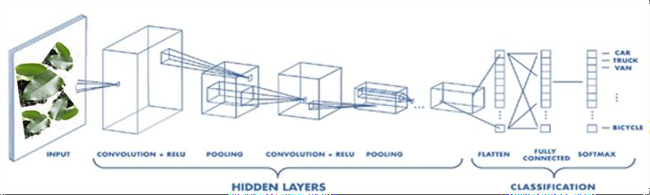

Fig 6.3 Convolution Neural Network Architecture

# 6.3.1 Convolution Layer

The convolution layer is the core building block of the CNN. It carries the main portion of the network computation load. This layer performs a dot product between two matrices where one matrix is the set of learnable parameters otherwise known as a kernel and the other matrix is the restricted portion of the receptive field. The kernel is spatially smaller than an image but is more in-depth. This mean that if the image is composed of three channels the kernel height and width will be spatially small but the depth extends up to all three channels.

## 𝑊𝑜 𝑢𝑡 = (𝑊 − 𝐹 + 2𝑃)/𝑆 + 1

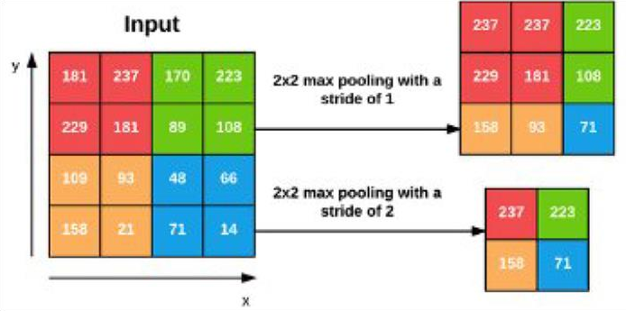

Fig 6.3.1 Convolutional Layer

# 6.3.2 Pooling Layer

The pooling layer replace the output of the network at certain location by deriving a summary statistic of the nearby output. This helps in reducing the spatial size of the representation which decreases the required amount of computation and weights. The pooling operation is processed on every slice of the representation individually. There are several pooling function such as the average of the rectangular neighborhood, and a weighted average based on the distance from the central pixel. However the most popular process is max pooling which report the maximum output from the neighborhood.

**6.3.2.1 Max pooling**

This works by selecting the maximum cost from every pool. Max pooling retains the maximum distinguished features of the characteristic map, and the returned picture is sharper than the authentic picture.

**6.3.2.2 Average pooling**

This pooling layer works by getting the common of the pool. Average pooling retains the common values of functions of the characteristic map. It smoothes the photograph while retaining the essence of the function in an image.

Why pooling layers are needed?

The function map produced with the aid of the filters of convolutional layers is area-structured. As an instance, if an object in an image has shifted a chunk it might not be recognizable via the convolutional layer. So, it manner that the feature map statistics the proper positions of features within the enter. What pooling layers offer is “translational invariance” which makes the cnn invariant to translations, i.e., even supposing the input of the cnn is translated, the cnn will still be able to recognize the capabilities in the input.

# 6.3.3 Fully Connected Layer

Neurons in this layer have full connectivity with all neurons in the preceding and succeeding layer as seen in regular FCNN. This is why it can be computed as usual by a matrix multiplication followed by a bias effect. The FC layer helps to map the representation between the input and output. A totally linked layer multiplies the input through a weight matrix after which provides a bias vector. The convolutional (and down-sampling) layers are observed through one or more completely connected layers. Because the call suggests, all neurons in a fully related layer hook up with all of the neurons within the preceding layer.

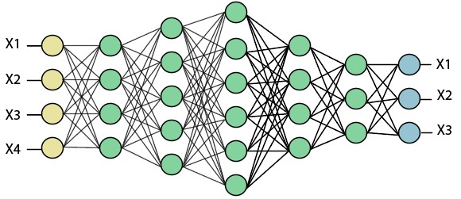

Fig 6.3.3 Fully Connected Layer

# 6.3.4 Dropout Layer

Dropout is a regularization technique used to lessen over-fitting on neural networks. Typically, deep studying fashions use dropout on the absolutely linked layers, but is likewise possible to use dropout after the max-pooling layers, developing photo noise augmentation. Dropout randomly zeroes some of the connections of the enter tensor with chance p using samples from a Bernoulli distribution.

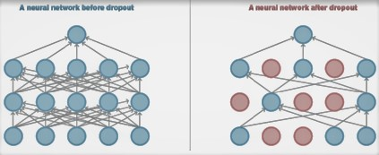

# Fig 6.3.4 Dropout Layer

# 6.3.5 Relu (Rectifier linear unit) Activation function

Activation features introduce non-linearity to the model which allows it to analyze complicated useful mappings among the inputs and reaction variables. There are quite some exclusive activation features like sigmoid, tanh, relu, leaky relu, and so on. Relu function is a piecewise linear feature that outputs the enter directly if is effective i. E. > 0, otherwise, it'll output zero. There are many other activation function however relu is the most used activation function for many varieties of neural networks as because of it’s linear behavior it is less difficult to educate and it regularly achieves higher performance.

**ReLU(x)=max(0,x)**

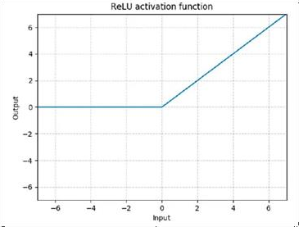

Fig 6.3.5 Relu

**07. RESULTS**

**7.1 Alex net Epoch 100**

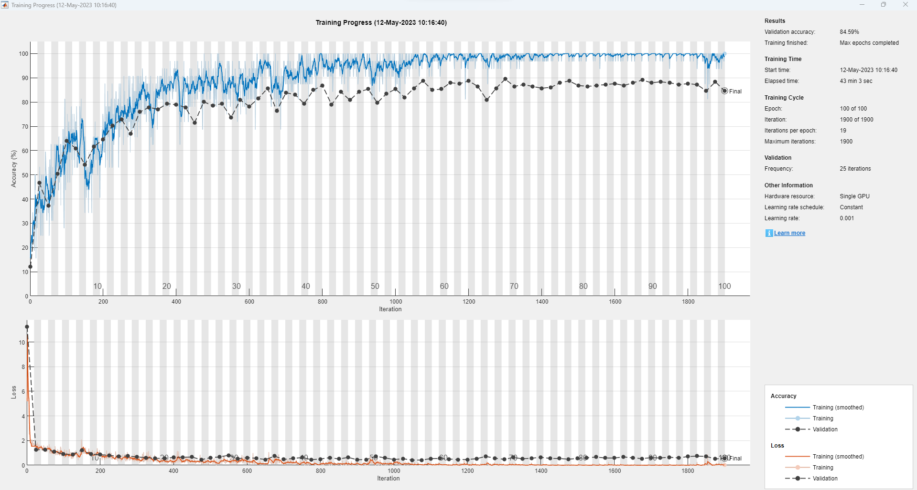

Fig 7.1 AlexNet Result

inputSize = 227 227 3

numClasses = 8

Training on single GPU.

Initializing input data normalization.

|======================================================================================================================|

| Epoch | Iteration | Time Elapsed | Mini-batch | Validation | Mini-batch | Validation | Base Learning |

| | | (hh:mm:ss) | Accuracy | Accuracy | Loss | Loss | Rate |

|======================================================================================================================|

| 1 | 1 | 00:00:13 | 15.62% | 12.03% | 5.1902 | 11.2442 | 0.0010 |

| 2 | 25 | 00:00:47 | 40.62% | 46.62% | 1.4335 | 1.2678 | 0.0010 |

| 3 | 50 | 00:01:20 | 34.38% | 37.22% | 1.4895 | 1.2535 | 0.0010 |

| 4 | 75 | 00:01:53 | 53.12% | 50.38% | 1.2434 | 1.1225 | 0.0010 |

| 6 | 100 | 00:02:28 | 65.62% | 63.91% | 0.9113 | 0.8989 | 0.0010 |

| 7 | 125 | 00:03:02 | 71.88% | 60.90% | 0.6517 | 0.8825 | 0.0010 |

| 8 | 150 | 00:03:35 | 34.38% | 54.14% | 1.5886 | 1.2232 | 0.0010 |

| 10 | 175 | 00:04:10 | 53.12% | 61.65% | 1.0115 | 0.8934 | 0.0010 |

| 11 | 200 | 00:04:43 | 71.88% | 64.66% | 0.7233 | 0.8526 | 0.0010 |

| 12 | 225 | 00:05:16 | 56.25% | 70.30% | 0.9990 | 0.7988 | 0.0010 |

| 14 | 250 | 00:05:50 | 78.12% | 72.93% | 0.7540 | 0.7253 | 0.0010 |

| 15 | 275 | 00:06:24 | 75.00% | 66.92% | 0.4836 | 0.7544 | 0.0010 |

| 16 | 300 | 00:06:57 | 87.50% | 75.94% | 0.3304 | 0.6690 | 0.0010 |

| 18 | 325 | 00:07:31 | 71.88% | 77.82% | 0.6444 | 0.6175 | 0.0010 |

| 19 | 350 | 00:08:04 | 84.38% | 77.07% | 0.5492 | 0.5626 | 0.0010 |

| 20 | 375 | 00:08:38 | 84.38% | 79.32% | 0.3414 | 0.5445 | 0.0010 |

| 22 | 400 | 00:09:11 | 84.38% | 78.95% | 0.3956 | 0.6393 | 0.0010 |

| 23 | 425 | 00:09:45 | 84.38% | 77.82% | 0.4287 | 0.6433 | 0.0010 |

| 24 | 450 | 00:10:19 | 90.62% | 71.43% | 0.1956 | 0.6665 | 0.0010 |

| 25 | 475 | 00:10:51 | 81.25% | 80.08% | 0.3577 | 0.4432 | 0.0010 |

| 27 | 500 | 00:11:27 | 90.62% | 78.57% | 0.1931 | 0.6124 | 0.0010 |

| 28 | 525 | 00:12:02 | 96.88% | 79.32% | 0.0927 | 0.6703 | 0.0010 |

| 29 | 550 | 00:12:34 | 90.62% | 73.68% | 0.2929 | 0.8116 | 0.0010 |

| 31 | 575 | 00:13:09 | 93.75% | 80.83% | 0.2327 | 0.5337 | 0.0010 |

| 32 | 600 | 00:13:42 | 90.62% | 78.20% | 0.2458 | 0.6143 | 0.0010 |

| 33 | 625 | 00:14:15 | 93.75% | 81.58% | 0.1979 | 0.5619 | 0.0010 |

| 35 | 650 | 00:14:49 | 93.75% | 85.71% | 0.1031 | 0.4613 | 0.0010 |

| 36 | 675 | 00:15:23 | 90.62% | 76.32% | 0.2838 | 0.7389 | 0.0010 |

| 37 | 700 | 00:15:56 | 93.75% | 83.83% | 0.1031 | 0.4658 | 0.0010 |

| 39 | 725 | 00:16:31 | 93.75% | 83.08% | 0.1052 | 0.5498 | 0.0010 |

| 40 | 750 | 00:17:04 | 90.62% | 79.32% | 0.1315 | 0.6272 | 0.0010 |

| 41 | 775 | 00:17:37 | 96.88% | 84.96% | 0.0878 | 0.4504 | 0.0010 |

| 43 | 800 | 00:18:11 | 96.88% | 86.84% | 0.1471 | 0.5029 | 0.0010 |

| 44 | 825 | 00:18:45 | 90.62% | 78.95% | 0.4033 | 0.6188 | 0.0010 |

| 45 | 850 | 00:19:18 | 96.88% | 84.21% | 0.0741 | 0.5047 | 0.0010 |

| 47 | 875 | 00:19:52 | 96.88% | 80.83% | 0.0583 | 0.6337 | 0.0010 |

| 48 | 900 | 00:20:26 | 93.75% | 84.21% | 0.2034 | 0.4448 | 0.0010 |

| 49 | 925 | 00:21:00 | 93.75% | 85.34% | 0.0981 | 0.4605 | 0.0010 |

| 50 | 950 | 00:21:33 | 100.00% | 79.70% | 0.0367 | 0.7276 | 0.0010 |

| 52 | 975 | 00:22:08 | 84.38% | 83.46% | 0.3212 | 0.5943 | 0.0010 |

| 53 | 1000 | 00:22:41 | 84.38% | 85.34% | 0.5214 | 0.4638 | 0.0010 |

| 54 | 1025 | 00:23:14 | 90.62% | 81.95% | 0.1586 | 0.5195 | 0.0010 |

| 56 | 1050 | 00:23:45 | 96.88% | 85.71% | 0.1728 | 0.4165 | 0.0010 |

| 57 | 1075 | 00:24:15 | 100.00% | 88.72% | 0.0558 | 0.4190 | 0.0010 |

| 58 | 1100 | 00:24:46 | 100.00% | 84.96% | 0.0108 | 0.5348 | 0.0010 |

| 60 | 1125 | 00:25:21 | 100.00% | 85.34% | 0.0052 | 0.5458 | 0.0010 |

| 61 | 1150 | 00:25:56 | 96.88% | 87.97% | 0.0362 | 0.4993 | 0.0010 |

| 62 | 1175 | 00:26:32 | 100.00% | 87.59% | 0.0030 | 0.4600 | 0.0010 |

| 64 | 1200 | 00:27:09 | 100.00% | 88.72% | 0.0084 | 0.4634 | 0.0010 |

| 65 | 1225 | 00:27:45 | 100.00% | 86.47% | 0.0023 | 0.5308 | 0.0010 |

| 66 | 1250 | 00:28:19 | 100.00% | 80.83% | 0.0175 | 0.7133 | 0.0010 |

| 68 | 1275 | 00:28:55 | 100.00% | 85.71% | 0.0178 | 0.5708 | 0.0010 |

| 69 | 1300 | 00:29:29 | 100.00% | 89.47% | 0.0041 | 0.4776 | 0.0010 |

| 70 | 1325 | 00:30:04 | 100.00% | 86.47% | 0.0044 | 0.6248 | 0.0010 |

| 72 | 1350 | 00:30:42 | 96.88% | 87.22% | 0.0788 | 0.5215 | 0.0010 |

| 73 | 1375 | 00:31:17 | 96.88% | 86.47% | 0.0335 | 0.5726 | 0.0010 |

| 74 | 1400 | 00:31:53 | 100.00% | 85.71% | 0.0092 | 0.6398 | 0.0010 |

| 75 | 1425 | 00:32:28 | 100.00% | 86.09% | 0.0082 | 0.5543 | 0.0010 |

| 77 | 1450 | 00:33:05 | 100.00% | 87.97% | 0.0055 | 0.5449 | 0.0010 |

| 78 | 1475 | 00:33:40 | 96.88% | 88.72% | 0.0460 | 0.4929 | 0.0010 |

| 79 | 1500 | 00:34:13 | 100.00% | 86.84% | 0.0004 | 0.5458 | 0.0010 |

| 81 | 1525 | 00:34:48 | 100.00% | 86.47% | 0.0004 | 0.6010 | 0.0010 |

| 82 | 1550 | 00:35:21 | 100.00% | 86.84% | 0.0005 | 0.6606 | 0.0010 |

| 83 | 1575 | 00:35:55 | 100.00% | 87.22% | 0.0084 | 0.5872 | 0.0010 |

| 85 | 1600 | 00:36:28 | 100.00% | 87.59% | 0.0006 | 0.5823 | 0.0010 |

| 86 | 1625 | 00:37:00 | 100.00% | 86.84% | 0.0003 | 0.6739 | 0.0010 |

| 87 | 1650 | 00:37:31 | 100.00% | 87.97% | 0.0005 | 0.5951 | 0.0010 |

| 89 | 1675 | 00:38:04 | 100.00% | 89.10% | 0.0001 | 0.5397 | 0.0010 |

| 90 | 1700 | 00:38:35 | 100.00% | 87.97% | 0.0005 | 0.6089 | 0.0010 |

| 91 | 1725 | 00:39:06 | 100.00% | 88.35% | 0.0041 | 0.5915 | 0.0010 |

| 93 | 1750 | 00:39:38 | 93.75% | 87.97% | 0.0883 | 0.6502 | 0.0010 |

| 94 | 1775 | 00:40:10 | 100.00% | 87.22% | 0.0002 | 0.5902 | 0.0010 |

| 95 | 1800 | 00:40:44 | 100.00% | 87.59% | 0.0129 | 0.7060 | 0.0010 |

| 97 | 1825 | 00:41:17 | 93.75% | 87.22% | 0.2502 | 0.7362 | 0.0010 |

| 98 | 1850 | 00:41:51 | 100.00% | 84.59% | 0.0003 | 0.7156 | 0.0010 |

| 99 | 1875 | 00:42:24 | 96.88% | 88.35% | 0.0996 | 0.5102 | 0.0010 |

| 100 | 1900 | 00:42:57 | 100.00% | 84.59% | 0.0349 | 0.5671 | 0.0010 |

|======================================================================================================================|

Training finished: Max epochs completed.

**accuracy = 0.8459**

**7.2 GoogleNet Epoch100:**

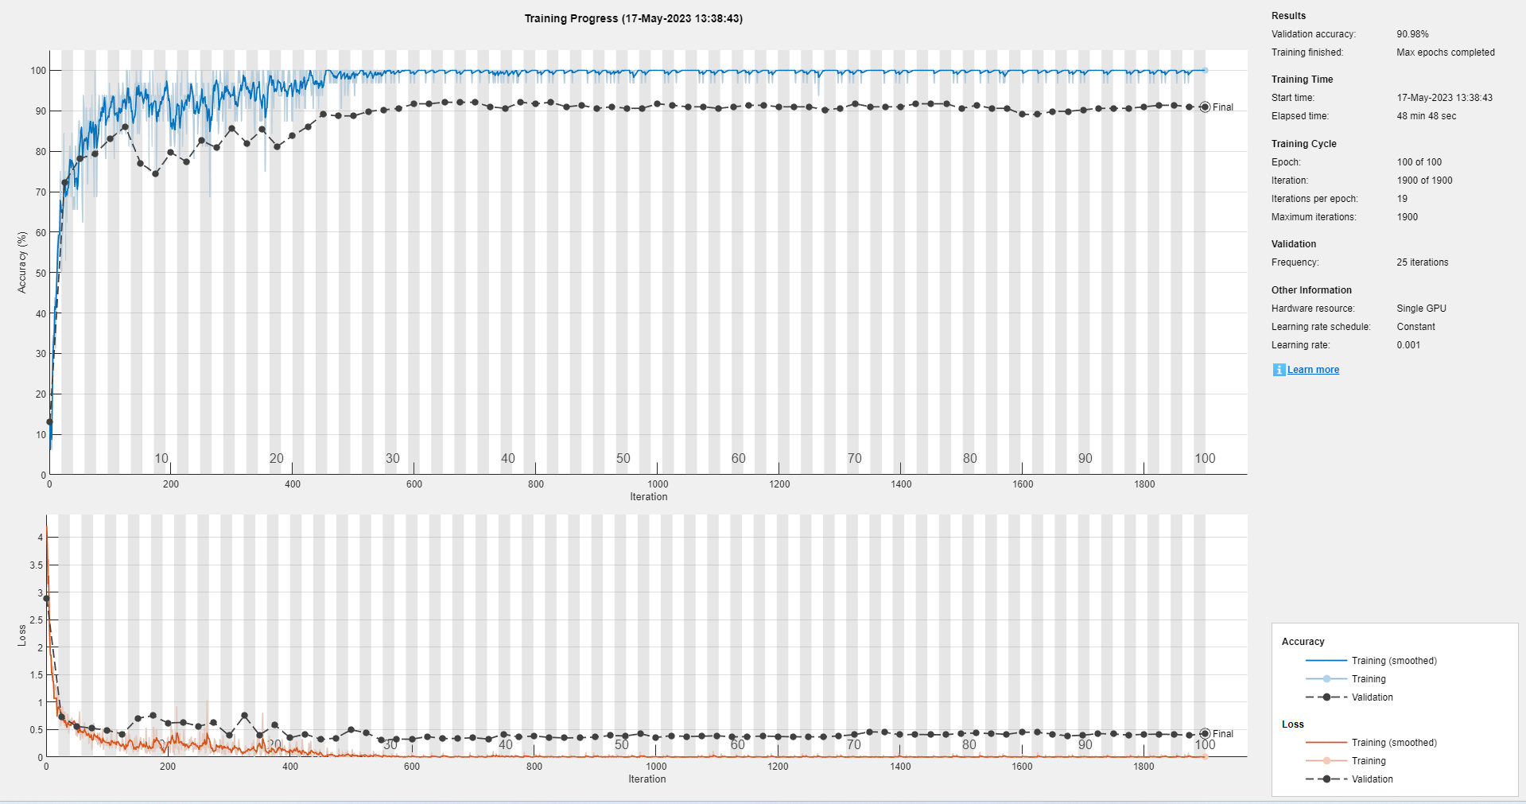

Fig 7.2 GoogleNet Result

googlenet1

Training on single GPU.

Initializing input data normalization.

|======================================================================================================================|

| Epoch | Iteration | Time Elapsed | Mini-batch | Validation | Mini-batch | Validation | Base Learning |

| | | (hh:mm:ss) | Accuracy | Accuracy | Loss | Loss | Rate |

|======================================================================================================================|

| 1 | 1 | 00:00:10 | 12.50% | 13.16% | 4.2020 | 2.8818 | 0.0010 |

| 2 | 25 | 00:00:48 | 68.75% | 72.18% | 0.8721 | 0.7357 | 0.0010 |

| 3 | 50 | 00:01:27 | 84.38% | 78.20% | 0.5513 | 0.5606 | 0.0010 |

| 4 | 75 | 00:02:05 | 100.00% | 79.32% | 0.1255 | 0.5236 | 0.0010 |

| 6 | 100 | 00:02:44 | 90.62% | 83.08% | 0.3522 | 0.4893 | 0.0010 |

| 7 | 125 | 00:03:24 | 87.50% | 86.09% | 0.3383 | 0.4190 | 0.0010 |

| 8 | 150 | 00:04:03 | 100.00% | 77.07% | 0.1000 | 0.7055 | 0.0010 |

| 10 | 175 | 00:04:42 | 93.75% | 74.44% | 0.0983 | 0.7524 | 0.0010 |

| 11 | 200 | 00:05:22 | 81.25% | 79.70% | 0.3642 | 0.6197 | 0.0010 |

| 12 | 225 | 00:06:01 | 87.50% | 77.44% | 0.2802 | 0.6315 | 0.0010 |

| 14 | 250 | 00:06:40 | 93.75% | 82.71% | 0.1312 | 0.5611 | 0.0010 |

| 15 | 275 | 00:07:20 | 100.00% | 80.83% | 0.0537 | 0.6263 | 0.0010 |

| 16 | 300 | 00:07:58 | 96.88% | 85.71% | 0.0959 | 0.3910 | 0.0010 |

| 18 | 325 | 00:08:38 | 96.88% | 81.95% | 0.0858 | 0.7531 | 0.0010 |

| 19 | 350 | 00:09:17 | 87.50% | 85.34% | 0.2551 | 0.4016 | 0.0010 |

| 20 | 375 | 00:09:56 | 100.00% | 81.20% | 0.0421 | 0.5840 | 0.0010 |

| 22 | 400 | 00:10:35 | 87.50% | 83.83% | 0.2236 | 0.3514 | 0.0010 |

| 23 | 425 | 00:11:14 | 100.00% | 86.09% | 0.0210 | 0.4178 | 0.0010 |

| 24 | 450 | 00:11:53 | 96.88% | 89.10% | 0.0406 | 0.3235 | 0.0010 |

| 25 | 475 | 00:12:32 | 100.00% | 88.72% | 0.0150 | 0.3449 | 0.0010 |

| 27 | 500 | 00:13:12 | 100.00% | 88.72% | 0.0147 | 0.4953 | 0.0010 |

| 28 | 525 | 00:13:52 | 100.00% | 89.85% | 0.0051 | 0.4435 | 0.0010 |

| 29 | 550 | 00:14:31 | 100.00% | 90.23% | 0.0066 | 0.3063 | 0.0010 |

| 31 | 575 | 00:15:06 | 96.88% | 90.60% | 0.0629 | 0.3268 | 0.0010 |

| 32 | 600 | 00:15:42 | 96.88% | 91.73% | 0.0720 | 0.3258 | 0.0010 |

| 33 | 625 | 00:16:16 | 100.00% | 91.73% | 0.0035 | 0.3745 | 0.0010 |

| 35 | 650 | 00:16:52 | 100.00% | 92.11% | 0.0046 | 0.3356 | 0.0010 |

| 36 | 675 | 00:17:27 | 100.00% | 92.11% | 0.0006 | 0.3395 | 0.0010 |

| 37 | 700 | 00:18:02 | 100.00% | 92.11% | 0.0011 | 0.3515 | 0.0010 |

| 39 | 725 | 00:18:38 | 100.00% | 90.98% | 0.0018 | 0.3294 | 0.0010 |

| 40 | 750 | 00:19:13 | 100.00% | 90.60% | 0.0032 | 0.4154 | 0.0010 |

| 41 | 775 | 00:19:48 | 100.00% | 92.11% | 0.0007 | 0.3679 | 0.0010 |

| 43 | 800 | 00:20:24 | 100.00% | 91.73% | 0.0129 | 0.3818 | 0.0010 |

| 44 | 825 | 00:20:59 | 100.00% | 92.11% | 0.0011 | 0.3592 | 0.0010 |

| 45 | 850 | 00:21:34 | 100.00% | 90.98% | 0.0017 | 0.3479 | 0.0010 |

| 47 | 875 | 00:22:10 | 100.00% | 91.35% | 0.0002 | 0.3525 | 0.0010 |

| 48 | 900 | 00:22:45 | 100.00% | 90.60% | 0.0008 | 0.3631 | 0.0010 |

| 49 | 925 | 00:23:20 | 100.00% | 90.98% | 0.0003 | 0.3922 | 0.0010 |

| 50 | 950 | 00:23:56 | 100.00% | 90.60% | 0.0005 | 0.3850 | 0.0010 |

| 52 | 975 | 00:24:33 | 100.00% | 90.60% | 0.0007 | 0.4249 | 0.0010 |

| 53 | 1000 | 00:25:13 | 100.00% | 91.73% | 0.0058 | 0.3566 | 0.0010 |

| 54 | 1025 | 00:25:52 | 100.00% | 91.35% | 0.0003 | 0.3898 | 0.0010 |

| 56 | 1050 | 00:26:32 | 100.00% | 90.98% | 0.0091 | 0.3758 | 0.0010 |

| 57 | 1075 | 00:27:13 | 96.88% | 90.98% | 0.0308 | 0.3782 | 0.0010 |

| 58 | 1100 | 00:27:54 | 100.00% | 90.60% | 0.0004 | 0.3891 | 0.0010 |

| 60 | 1125 | 00:28:36 | 100.00% | 90.98% | 0.0012 | 0.3667 | 0.0010 |

| 61 | 1150 | 00:29:16 | 100.00% | 91.35% | 0.0001 | 0.3731 | 0.0010 |

| 62 | 1175 | 00:29:50 | 100.00% | 91.35% | 0.0014 | 0.3824 | 0.0010 |

| 64 | 1200 | 00:30:25 | 100.00% | 90.98% | 0.0010 | 0.3750 | 0.0010 |

| 65 | 1225 | 00:31:00 | 100.00% | 90.98% | 0.0005 | 0.3680 | 0.0010 |

| 66 | 1250 | 00:31:35 | 100.00% | 90.98% | 0.0012 | 0.3701 | 0.0010 |

| 68 | 1275 | 00:32:10 | 100.00% | 90.23% | 0.0020 | 0.3660 | 0.0010 |

| 69 | 1300 | 00:32:45 | 100.00% | 90.60% | 0.0002 | 0.3859 | 0.0010 |

| 70 | 1325 | 00:33:19 | 100.00% | 91.73% | 0.0035 | 0.4065 | 0.0010 |

| 72 | 1350 | 00:33:56 | 100.00% | 90.98% | 0.0008 | 0.4604 | 0.0010 |

| 73 | 1375 | 00:34:37 | 100.00% | 90.98% | 0.0003 | 0.4516 | 0.0010 |

| 74 | 1400 | 00:35:16 | 100.00% | 90.98% | 7.7500e-05 | 0.4066 | 0.0010 |

| 75 | 1425 | 00:35:56 | 100.00% | 91.73% | 0.0008 | 0.4116 | 0.0010 |

| 77 | 1450 | 00:36:38 | 100.00% | 91.73% | 0.0001 | 0.4081 | 0.0010 |

| 78 | 1475 | 00:37:18 | 100.00% | 91.73% | 0.0003 | 0.4060 | 0.0010 |

| 79 | 1500 | 00:37:56 | 100.00% | 90.60% | 0.0001 | 0.4327 | 0.0010 |

| 81 | 1525 | 00:38:37 | 100.00% | 91.35% | 0.0099 | 0.4347 | 0.0010 |

| 82 | 1550 | 00:39:17 | 100.00% | 90.60% | 0.0212 | 0.4290 | 0.0010 |

| 83 | 1575 | 00:39:57 | 100.00% | 90.60% | 0.0006 | 0.4135 | 0.0010 |

| 85 | 1600 | 00:40:37 | 100.00% | 89.10% | 3.2750e-05 | 0.4531 | 0.0010 |

| 86 | 1625 | 00:41:18 | 100.00% | 89.10% | 0.0002 | 0.4505 | 0.0010 |

| 87 | 1650 | 00:41:58 | 100.00% | 89.85% | 0.0005 | 0.4191 | 0.0010 |

| 89 | 1675 | 00:42:39 | 100.00% | 89.85% | 0.0041 | 0.3854 | 0.0010 |

| 90 | 1700 | 00:43:20 | 100.00% | 90.23% | 0.0003 | 0.3984 | 0.0010 |

| 91 | 1725 | 00:43:59 | 100.00% | 90.60% | 0.0009 | 0.4265 | 0.0010 |

| 93 | 1750 | 00:44:40 | 100.00% | 90.60% | 0.0015 | 0.4200 | 0.0010 |

| 94 | 1775 | 00:45:20 | 100.00% | 90.60% | 0.0004 | 0.4007 | 0.0010 |

| 95 | 1800 | 00:46:00 | 100.00% | 90.98% | 5.6427e-05 | 0.4147 | 0.0010 |

| 97 | 1825 | 00:46:44 | 100.00% | 91.35% | 0.0002 | 0.4155 | 0.0010 |

| 98 | 1850 | 00:47:24 | 100.00% | 91.35% | 0.0004 | 0.4111 | 0.0010 |

| 99 | 1875 | 00:48:03 | 100.00% | 90.98% | 2.2830e-05 | 0.3971 | 0.0010 |

| 100 | 1900 | 00:48:42 | 100.00% | 90.98% | 4.2093e-05 | 0.4280 | 0.0010 |

|============================================================================================

**accuracy = 0.9098**

**7.3 Own Network Epoch 100**

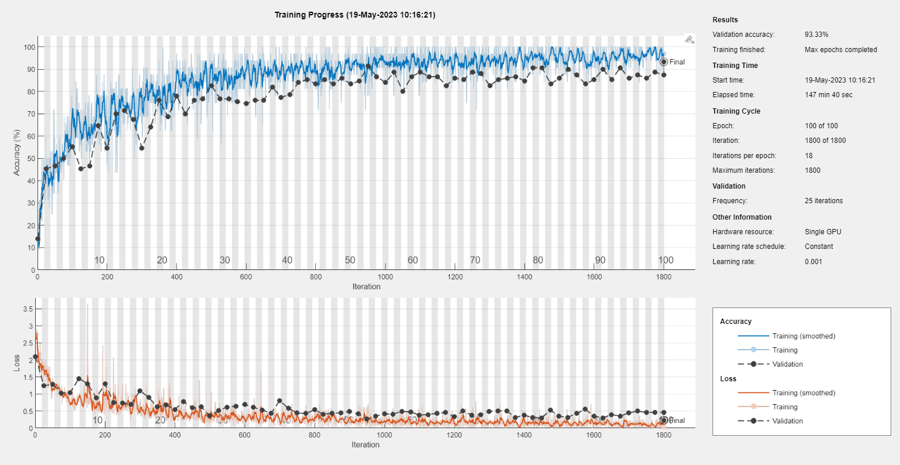

Fig 7.3 Own Network Result

Training on single GPU.

Initializing input data normalization.

|======================================================================================================================|

| Epoch | Iteration | Time Elapsed | Mini-batch | Validation | Mini-batch | Validation | Base Learning |

| | | (hh:mm:ss) | Accuracy | Accuracy | Loss | Loss | Rate |

|======================================================================================================================|

| 1 | 1 | 00:00:30 | 12.50% | 14.00% | 2.6170 | 2.1000 | 0.0010 |

| 2 | 25 | 00:02:46 | 37.50% | 45.33% | 1.7343 | 1.2445 | 0.0010 |

| 3 | 50 | 00:05:12 | 59.38% | 46.67% | 1.2294 | 1.2802 | 0.0010 |

| 5 | 75 | 00:07:35 | 53.12% | 50.00% | 0.9966 | 1.0280 | 0.0010 |

| 6 | 100 | 00:09:56 | 65.62% | 55.33% | 0.7472 | 1.0373 | 0.0010 |

| 7 | 125 | 00:12:15 | 71.88% | 45.33% | 0.8329 | 1.4553 | 0.0010 |

| 9 | 150 | 00:14:38 | 46.88% | 46.67% | 3.6412 | 1.3023 | 0.0010 |

| 10 | 175 | 00:16:59 | 78.12% | 64.67% | 0.5258 | 0.8884 | 0.0010 |

| 12 | 200 | 00:19:19 | 46.88% | 54.67% | 0.9962 | 1.2966 | 0.0010 |

| 13 | 225 | 00:21:40 | 78.12% | 70.00% | 0.5554 | 0.7542 | 0.0010 |

| 14 | 250 | 00:24:04 | 68.75% | 71.33% | 1.2765 | 0.7334 | 0.0010 |

| 16 | 275 | 00:26:20 | 75.00% | 67.33% | 0.5565 | 0.6997 | 0.0010 |

| 17 | 300 | 00:28:40 | 78.12% | 54.67% | 0.6041 | 1.0986 | 0.0010 |

| 19 | 325 | 00:31:03 | 84.38% | 64.00% | 0.3264 | 0.9024 | 0.0010 |

| 20 | 350 | 00:33:20 | 71.88% | 76.00% | 0.6471 | 0.6195 | 0.0010 |

| 21 | 375 | 00:35:10 | 78.12% | 68.67% | 0.4854 | 0.6780 | 0.0010 |

| 23 | 400 | 00:37:02 | 96.88% | 78.00% | 0.1810 | 0.5474 | 0.0010 |

| 24 | 425 | 00:38:54 | 87.50% | 70.00% | 0.2880 | 0.7804 | 0.0010 |

| 25 | 450 | 00:40:47 | 78.12% | 76.00% | 0.4472 | 0.5932 | 0.0010 |

| 27 | 475 | 00:42:40 | 84.38% | 76.67% | 0.3713 | 0.6211 | 0.0010 |

| 28 | 500 | 00:44:30 | 90.62% | 82.67% | 0.2154 | 0.3642 | 0.0010 |

| 30 | 525 | 00:46:24 | 90.62% | 76.67% | 0.2679 | 0.5147 | 0.0010 |

| 31 | 550 | 00:48:19 | 90.62% | 76.67% | 0.2073 | 0.6173 | 0.0010 |

| 32 | 575 | 00:50:14 | 84.38% | 75.33% | 0.3867 | 0.6457 | 0.0010 |

| 34 | 600 | 00:52:11 | 96.88% | 74.67% | 0.1301 | 0.6915 | 0.0010 |

| 35 | 625 | 00:54:04 | 93.75% | 76.00% | 0.1951 | 0.6061 | 0.0010 |

| 37 | 650 | 00:56:02 | 84.38% | 76.00% | 0.3502 | 0.5354 | 0.0010 |

| 38 | 675 | 00:58:00 | 87.50% | 82.00% | 0.2215 | 0.4294 | 0.0010 |

| 39 | 700 | 00:59:56 | 96.88% | 77.33% | 0.0819 | 0.8032 | 0.0010 |

| 41 | 725 | 01:01:53 | 87.50% | 78.67% | 0.2949 | 0.5805 | 0.0010 |

| 42 | 750 | 01:03:45 | 90.62% | 84.00% | 0.4081 | 0.4430 | 0.0010 |

| 44 | 775 | 01:05:42 | 81.25% | 85.33% | 0.6698 | 0.4279 | 0.0010 |

| 45 | 800 | 01:07:36 | 81.25% | 83.33% | 0.5038 | 0.5376 | 0.0010 |

| 46 | 825 | 01:09:40 | 90.62% | 85.33% | 0.3151 | 0.4081 | 0.0010 |

| 48 | 850 | 01:11:43 | 84.38% | 83.33% | 0.4266 | 0.4321 | 0.0010 |

| 49 | 875 | 01:13:47 | 90.62% | 86.00% | 0.2919 | 0.4494 | 0.0010 |

| 50 | 900 | 01:15:46 | 90.62% | 83.33% | 0.3234 | 0.4857 | 0.0010 |

| 52 | 925 | 01:17:56 | 90.62% | 84.67% | 0.2174 | 0.4168 | 0.0010 |

| 53 | 950 | 01:19:59 | 96.88% | 91.33% | 0.1274 | 0.2739 | 0.0010 |

| 55 | 975 | 01:21:58 | 87.50% | 86.67% | 0.3063 | 0.3563 | 0.0010 |

| 56 | 1000 | 01:23:54 | 87.50% | 84.00% | 0.3558 | 0.4138 | 0.0010 |

| 57 | 1025 | 01:25:49 | 90.62% | 88.67% | 0.2250 | 0.4124 | 0.0010 |

| 59 | 1050 | 01:27:44 | 93.75% | 80.00% | 0.1281 | 0.4916 | 0.0010 |

| 60 | 1075 | 01:29:37 | 93.75% | 86.67% | 0.2003 | 0.4718 | 0.0010 |

| 62 | 1100 | 01:31:37 | 100.00% | 88.67% | 0.0498 | 0.3844 | 0.0010 |

| 63 | 1125 | 01:33:32 | 100.00% | 86.67% | 0.0503 | 0.3987 | 0.0010 |

| 64 | 1150 | 01:35:23 | 87.50% | 86.67% | 0.3130 | 0.4358 | 0.0010 |

| 66 | 1175 | 01:37:20 | 90.62% | 82.67% | 0.2962 | 0.4568 | 0.0010 |

| 67 | 1200 | 01:39:16 | 100.00% | 86.00% | 0.0559 | 0.3403 | 0.0010 |

| 69 | 1225 | 01:41:09 | 87.50% | 85.33% | 0.4070 | 0.4954 | 0.0010 |

| 70 | 1250 | 01:43:05 | 90.62% | 88.67% | 0.2733 | 0.3803 | 0.0010 |

| 71 | 1275 | 01:45:01 | 96.88% | 88.00% | 0.1231 | 0.3930 | 0.0010 |

| 73 | 1300 | 01:46:55 | 93.75% | 82.67% | 0.1523 | 0.4890 | 0.0010 |

| 74 | 1325 | 01:48:55 | 100.00% | 85.33% | 0.0419 | 0.5084 | 0.0010 |

| 75 | 1350 | 01:51:01 | 87.50% | 86.00% | 0.2107 | 0.5025 | 0.0010 |

| 77 | 1375 | 01:53:08 | 84.38% | 86.67% | 0.3832 | 0.3159 | 0.0010 |

| 78 | 1400 | 01:55:18 | 100.00% | 84.67% | 0.0442 | 0.3771 | 0.0010 |

| 80 | 1425 | 01:57:25 | 100.00% | 90.67% | 0.0769 | 0.3120 | 0.0010 |

| 81 | 1450 | 01:59:34 | 93.75% | 90.67% | 0.1127 | 0.2925 | 0.0010 |

| 82 | 1475 | 02:01:37 | 100.00% | 83.33% | 0.0494 | 0.5276 | 0.0010 |

| 84 | 1500 | 02:03:52 | 100.00% | 86.00% | 0.0773 | 0.3467 | 0.0010 |

| 85 | 1525 | 02:05:58 | 96.88% | 90.00% | 0.0418 | 0.3135 | 0.0010 |

| 87 | 1550 | 02:08:03 | 96.88% | 87.33% | 0.0771 | 0.4309 | 0.0010 |

| 88 | 1575 | 02:10:01 | 96.88% | 83.33% | 0.0600 | 0.5518 | 0.0010 |

| 89 | 1600 | 02:11:52 | 90.62% | 85.33% | 0.3201 | 0.3573 | 0.0010 |

| 91 | 1625 | 02:13:45 | 100.00% | 90.00% | 0.0662 | 0.2977 | 0.0010 |

| 92 | 1650 | 02:15:46 | 100.00% | 85.33% | 0.0349 | 0.3983 | 0.0010 |

| 94 | 1675 | 02:17:48 | 100.00% | 90.67% | 0.0280 | 0.3520 | 0.0010 |

| 95 | 1700 | 02:19:45 | 90.62% | 86.00% | 0.2110 | 0.4487 | 0.0010 |

| 96 | 1725 | 02:21:42 | 93.75% | 87.33% | 0.1082 | 0.4979 | 0.0010 |

| 98 | 1750 | 02:23:41 | 96.88% | 86.00% | 0.0803 | 0.4601 | 0.0010 |

| 99 | 1775 | 02:25:38 | 100.00% | 88.67% | 0.0104 | 0.4628 | 0.0010 |

| 100 | 1800 | 02:27:33 | 96.88% | 87.33% | 0.0402 | 0.4595 | 0.0010 |

|======================================================================================================================|

accuracy = 93.33

**Precision, Recall values of the detection and identification results of different networks.**

|  |  |  |  |
| --- | --- | --- | --- |
| **Confusion Matrix Results 2** | | | |
| **Model** | **Classes** | **Precision** | **Recall** |
|  |  |  |  |
|  | White spot | 0.9474 | 0.9000 |
|  | Red leaf spot | 1.0000 | 0.9130 |
|  | Healthy | 0.8696 | 1.0000 |
| **AlexNet** | Gray blight | 0.9583 | 1.0000 |
|  | Brown blight | 1.0000 | 0.9500 |
|  | Bird’s eyespot | 1.0000 | 1.0000 |
|  | Anthracnose | 1.0000 | 0.9655 |
|  | Algal leaf spot | 0.9655 | 1.0000 |
|  |  |  |  |
|  | White spot | 0.8148 | 0.7333 |
|  | Red leaf spot | 1.0000 | 0.8235 |
|  | Healthy | 0.7879 | 0.8667 |
| **GoogleNet** | Gray blight | 0.7500 | 0.8333 |
|  | Brown blight | 0.8333 | 0.8333 |
|  | Bird’s eyespot | 1.0000 | 1.0000 |
|  | Anthracnose | 0.9773 | 1.0000 |
|  | Algal leaf spot | 0.7000 | 0.8140 |
|  |  |  |  |
|  | White spot | 1.0000 | 0.6000 |
|  | Red leaf spot | 1.0000 | 1.0000 |
|  | Healthy | 0.7692 | 1.0000 |
|  | Gray blight | 1.0000 | 1.0000 |
| **OwnNetwork** | Brown blight | 0.8182 | 0.9000 |
|  | Bird’s eyespot | 1.0000 | 1.0000 |
|  | Anthracnose | 1.0000 | 1.0000 |
|  | Algal leaf spot | 0.9833 | 1.0000 |

**Formula:-**

**precision = TP / (TP + FP);**

**recall = TP / (TP + FN);**

**7.4 AlexNet Confusion Matrix**

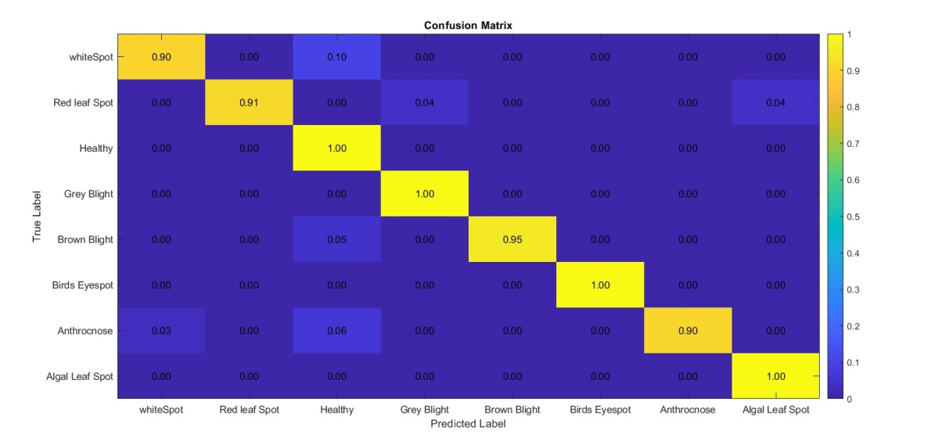

Fig 7.4 AlexNet Confusion Matrix

**7.5 GoogleNet Confusion Matrix**

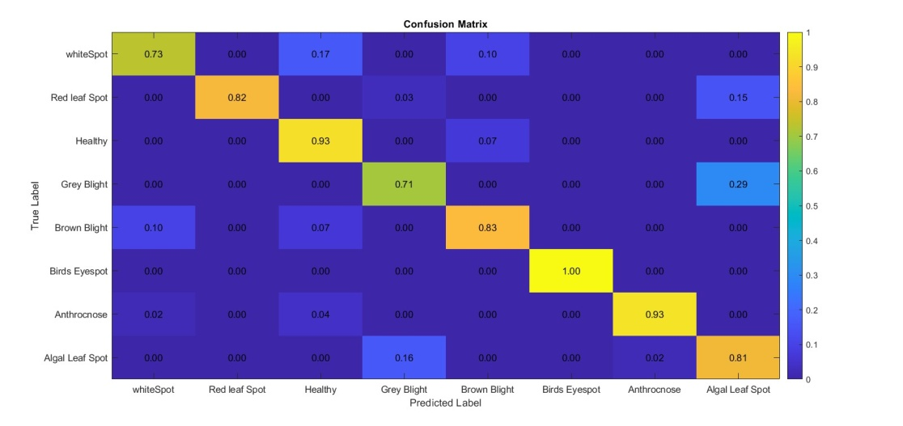

Fig 7.5 GoogleNet Confusion Matrix

**7.6 OwnNetwork Confusion Matrix**

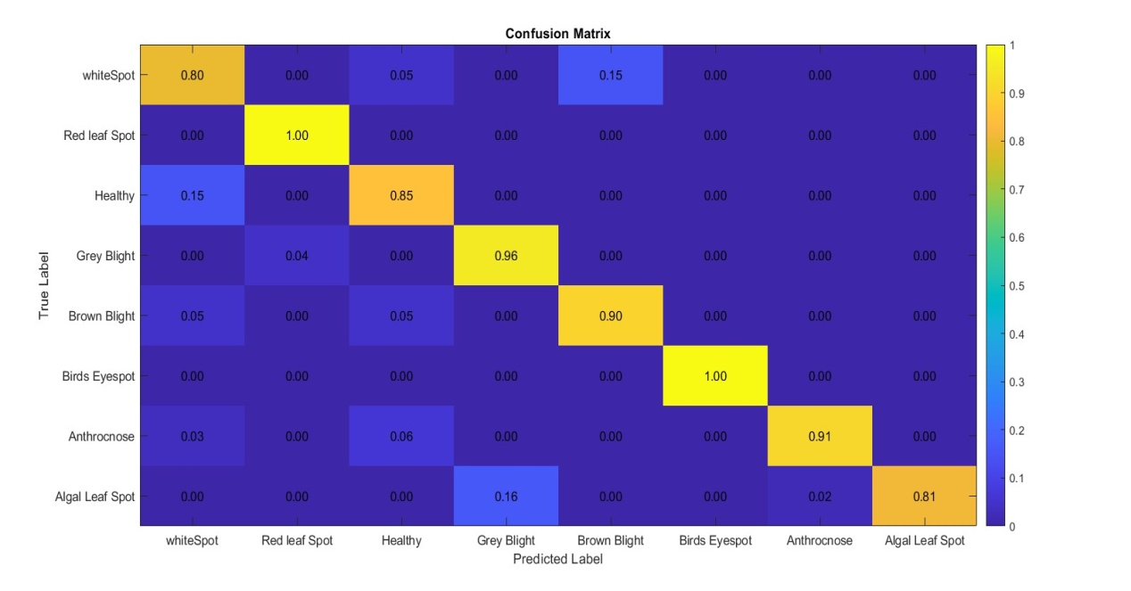

Fig 7.6 OwnNetwork Confusion Matrix

**09. Conclusion**

**9.1 Conclusion**

Generating and training of CNN model and gain accuracy. Our result shows that Trained model gives the accuracy using AlexNet and GoogleNet. In this Project 7 types of tea leaf disease images including one healthy leaf disease but in future we can increase the number of classes and modify the architecture accordingly to gain better accuracy.

**9.2 Future Scope**

* Future work We can also use an efficient model than this existing architecture on real time data for mobile based IoT application.
* Future work will involve spreading the usage of the model by training it for plant diseases recognition on wider land areas.

**10. References**

[1]. Sharma, V., Verma, A., & Goel, N. (2020). Classification techniques for plant disease detection. International Journal of Recent Technology and Engineering (IJRTE), 8(6), 5423.

[2]. Chen, J., & Jia, J. (2020). Automatic recognition of tea diseases based on deep learning.

[3]. Li, L., Zhang, S., & Wang, B. (2021). Plant disease detection and classification by deep learning — A review.

[4]. Hassan, S. M., Jasinski, M., Leonowicz, Z., Jasinska, E., & Maji, A. K. (2021). Plant Disease Identification Using Shallow Convolutional Neural Network. Agronomy, 11(12), 2388.

[5]. Bao, W., Fan, T., Hu, G., Liang, D., & Li, H. (2022). Detection and identification of tea leaf diseases based on AX‑RetinaNet. Scientific Reports, 12(1), 2183. https://doi.org/10.1038/s41598-022-06181-zk

[6]. Shaojuan Li, Lizhi Wang, Jia Li* and Yaun Yao, Image classification Algorithm Based on improved AlexNet,2021

[7]. Tasneen Gorach, Deep Convolutional neural networks, 2018.

[8]. Pouyan Salavati, Obstacle Detection Using GoogleNet,2018

# Appendix

# Appendix A

**Details of paper publication:**

**Name of the paper Journal:** International Journal of Creative Research Thoughts (IJCRT)

# Comments of Reviewer:

Dear Author,

Your submitted manuscript/paper (Registration ID:IJCRT_238132.)

has been Accepted for publication in the International Journal of Creative Research Thoughts

ISSN: 2320-2882.

---------- Forwarded message ---------

From: Editor IJCRT <editor@ijcrt.org>

Date: Sat, 27 May 2023, 4:22 pm

Subject: IJCRT_238132 - Paper Acceptance and review result

To: <shrikantsarode.sit.comp@gmail.com>

Dear Author,

Your submitted manuscript/paper (Registration ID:IJCRT_238132.) has been Accepted

for publication in the International Journal of Creative Research Thoughts ISSN: 2320-2882.

**Detection of Disease in Tea Leaves Using Convolution Neural Network**

## SHRIKANT SARODE, DIVYA SHINDE, DIPTI BEHARE, PRATYANK SONAWANE

**SINHGAD INSTITUTE OF TECHNOLOGY, LONAVLA**









